**Immigration Management System**

The Immigration Management System is a software system that aims to reduce the risk posed by immigrants and enable smooth flow of immigration at border points. It provides a centralized database that enables border officers to collect, safely input and manage immigrant’s data. The system determines the eligibility of the immigrants entering the country at border points and saves the various immigrant documents to be used to apply various legal travel and work permits. It also provides a portal where each immigrant can login to follow up on the various legal documents. Immigrant can manage their various types of documents over the Plateform such as Personal documents, Financial documents, Educational documents, Employment documents, Travel documents, Visas etc. There would be multiple options like upload documents, view uploaded documents, check documents status etc. to make the immigration process very smooth.

The Immigration Management System is developed using MERN Stack, which is a JavaScript stack that is used for easier and faster deployment of full-stack web applications. It comprises of 4 technologies: MongoDB, Express, React, andNode.js. 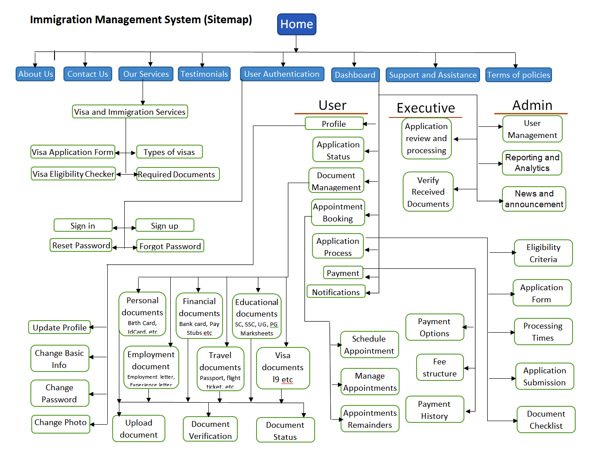

**Home Page:**

The homepage of the Immigration Management System is designed to be visually appealing and user-friendly, showcasing the company’s immigration services. A bold headline “Seamless Immigration Solutions Await You” is prominently displayed, inviting users to explore the offerings further. A well-designed illustration accompanies the text, featuring a person with luggage and an airplane in the background, symbolizing travel and relocation.

The top navigation bar includes options like “Home”, “About Us”, “Contact Us”, “Our Services”, “Dashboard”, and “Support & Asst.”, there will a human icon clicking on user can authenticate yourself. There is a large headline text that reads “Seamless IMMIGRATION Solutions Await You” in bold white letters against a dark background. Below the headline, there’s a call-to-action button labeled “Explore Now” encouraging users to learn more about the services offered 1. An illustration on the right side depicts a person holding luggage with speech bubbles, airplanes, and location pins floating around them indicating travel or relocation themes 1. The overall color scheme consists of dark blue, yellow and white creating contrast for easy readability.

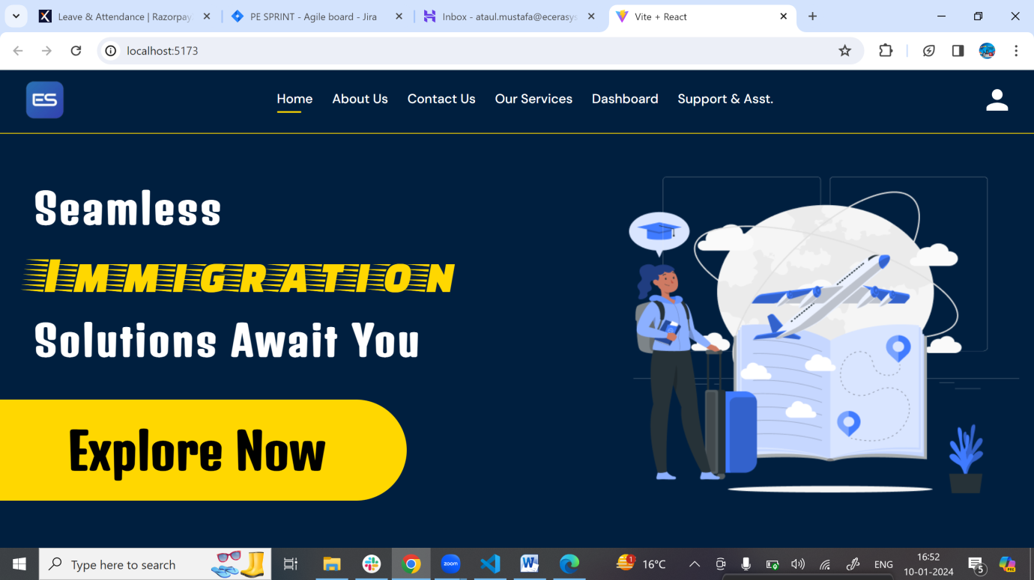

**SignUp/Registration Page:**

The signup/registration page for the Immigration Management System is designed to be user-friendly and easy to navigate. The page has a dark theme with yellow and blue accents 1. On the left side, there’s a large yellow oval containing welcoming text that reads “Welcome to ECERA SYSTEM” in bold letters. Below it reads “Authenticate yourself today, and enjoy the immigration process very smoothly.” There is an option to “SIGN IN” for users who already have an account.

On the right side of the page is the registration form under the header “Sign Up.” Fields for entering Name, Email, Phone No., Password, and Confirm Password are visible. Each field has validation requirements indicated below them such as “Name is required,” etc. A blue “Sign Up” button is at the bottom of the form for submission 1. The top navigation bar includes options like Home, About Us, Contact Us, Our Services, Dashboard, Support & Asst., and a user profile icon.

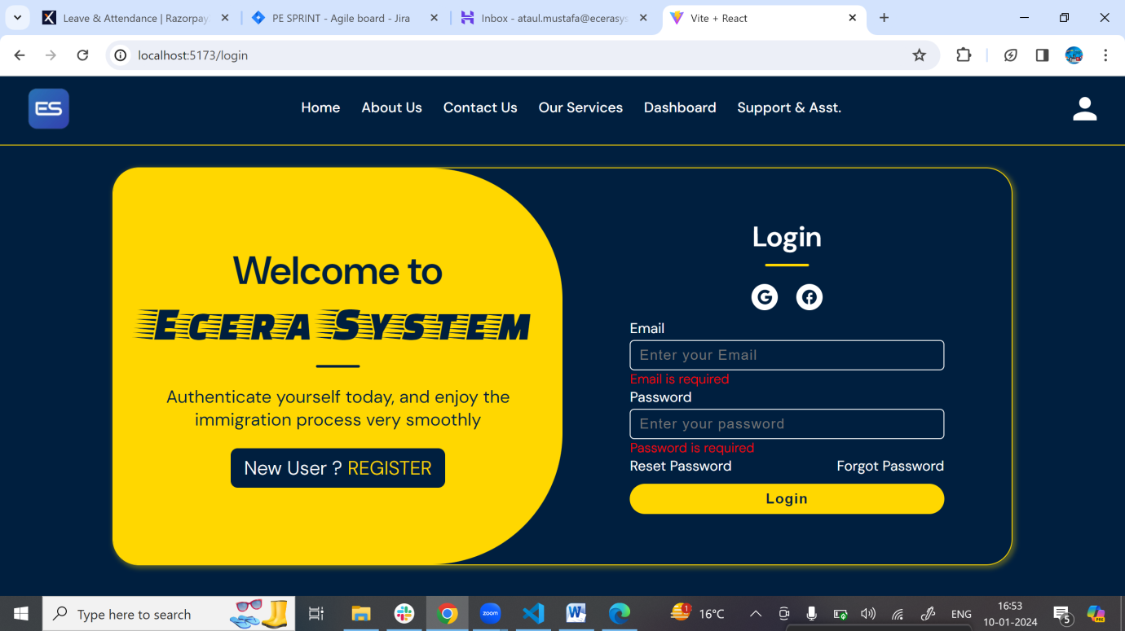

**User Dashboard:**

The user dashboard of the Immigration Management System is designed to be user-friendly and easy to navigate. The dashboard contains various options for managing documents, tracking application processes and statuses, booking appointments, and making payments 1. The top bar is dark blue with options like “Home”, “About Us”, “Contact Us”, “Our Services”, “Dashboard”, and “Support & Asst.” 1. On the left side, there is a yellow panel displaying the user’s name, along with an icon indicating it’s a user profile 1. Below the name are various options in white icons and text against a dark background: “My Profile”, “Doc. Management”, “Application Process”, “Application Status”, “Appointment Booking”, “Payment”, and “Logout” option at the bottom of the list 1. The main part of the screen to the right of this panel is empty and it is processing window where all operation will be perform, matching the color theme of the top bar 1. There are multiple tabs open in the web browser as indicated at the top of the image.

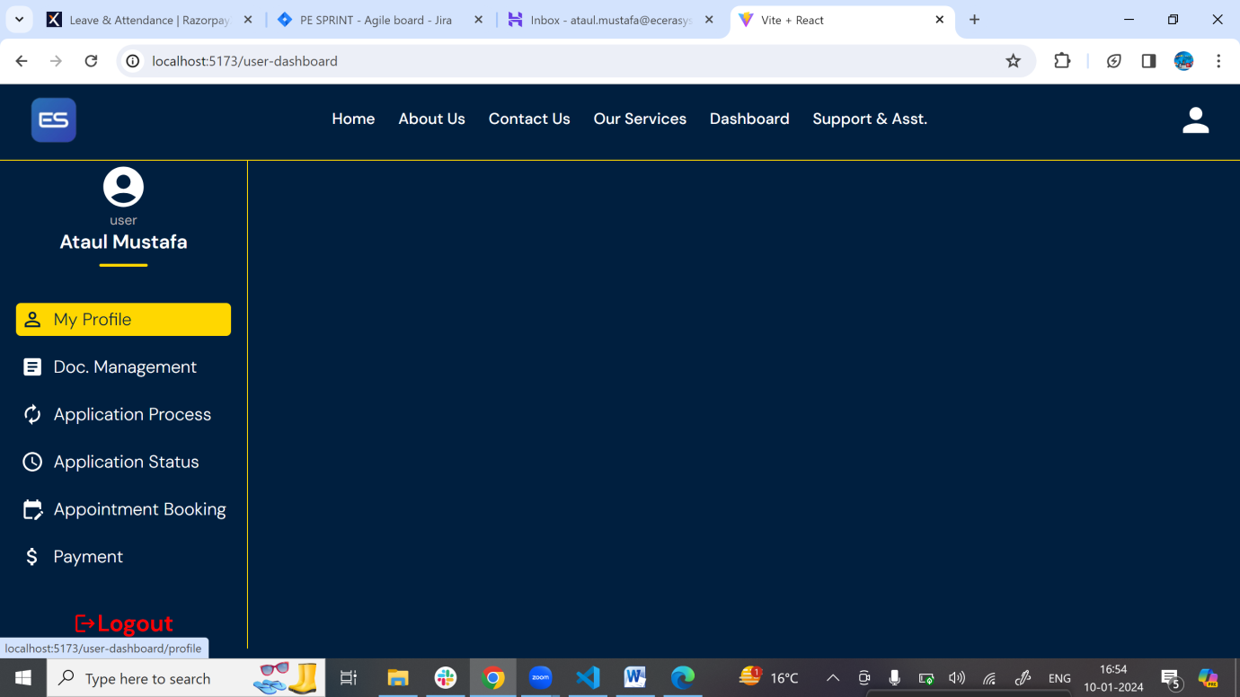

**Documents Management:**

Document management is a crucial aspect of the Immigration Management System. It refers to the process of handling, organizing, and storing documents in a systematic manner. The system provides a centralized platform for organizing, tracking, and managing all aspects of the immigration process. The document management feature allows users to store, organize, and access important documents related to each case. Whether it’s passports, visa applications, or supporting documentation, having all these files in one centralized location makes retrieving information easy.

The document management feature of the system includes the following key aspects:

**Organization**: Categorizing documents based on types, purposes, or other criteria for easy retrieval.

**Storage**: Utilizing physical or digital spaces to store documents securely.

**Access** Control: Implementing permissions to control who can access specific documents.

**Version Control**: Managing multiple versions of a document to track changes over time.

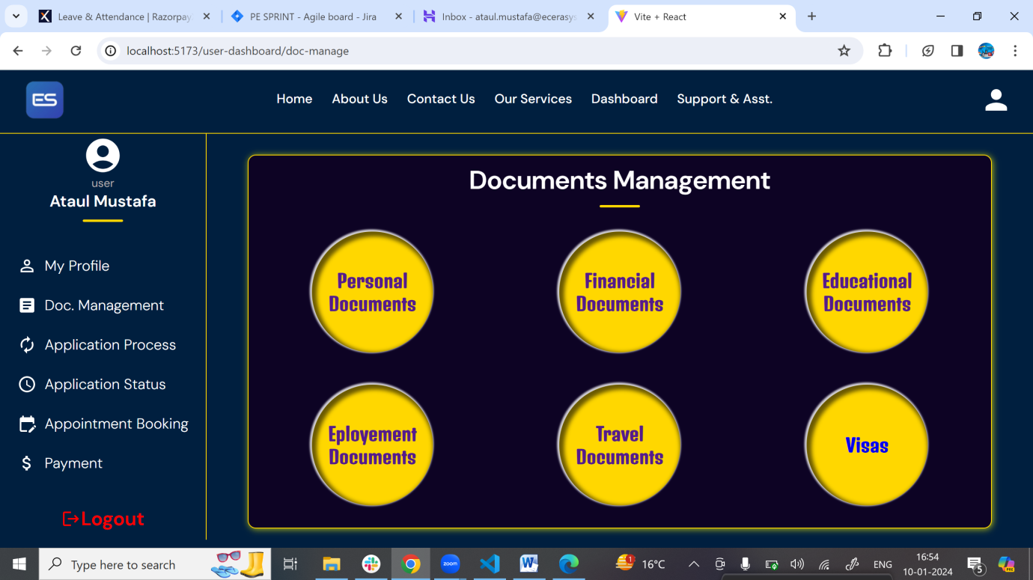

When any user will click on any of these document option then there will be open one another window that will having options to manage the documents like upload documents, check uploaded documents, check documents status etc.

